

A project by:

1. Vineet Sen (21bcs132)
2. Palash Bhasme (21bcs076)
3. Parth Pawar (21bcs083)

Course: Software Engineering

Prof: Dr. Uma S

**Introduction**

In an era driven by hectic schedules, constant distractions, and ever-increasing demands, individuals often find it challenging to maintain consistency and develop positive habits. The pursuit of personal growth and positive change can be overwhelming, leading many to struggle with achieving their goals. However, with the rise of technology, many new possibilities have opened up for the individuals wanting to inculcate positive habits into their lives.

This report introduces you to our app called ‘habits’, whose primary purpose is to assist the user in building new, positive habits by providing them the relevant data and necessary encouragement so that they stay consistent. Such an app can not only help you in building new habits but also assist in improving your time management skills by encouraging you to do certain things at certain times.

This app holds the potential to completely transform the lives of its users. As per the Journal of Medicine Internet Research, the people who used such habit tracking apps in building new habits had more motivation and adherence than those who did not use any.

By combining excellent UI/UX, intelligent data-driven insights and user-focused features, habits represents a huge step in leveraging the latest technology for personal growth.

**Requirements Elicitation**

The requirements that need to be addressed by the app are given below as follows:

1. User registration and authentication: Users should be able to create their accounts using their email addresses or Google account so that their data is saved in the cloud.
2. Habit creation and customisation: Users should be able to create and customize the habits as per their needs (name, reminders, weekdays).
3. Reminders as notifications: Users should receive the notifications on their devices as per their reminders settings.
4. Habit tracking and progress monitoring: Users should be able to view all the details about their progress with the help of visual cues along with the relevant data.
5. Streaks and rewards: Users should be able to set streaks to help them remain motivated. They should also receive rewards for reaching certain milestones in their journey.
6. User Experience and User interface: The app should provide a very easy-to-use and intuitive UI that is also very attractive. It should also avoid any bloat functionalities.

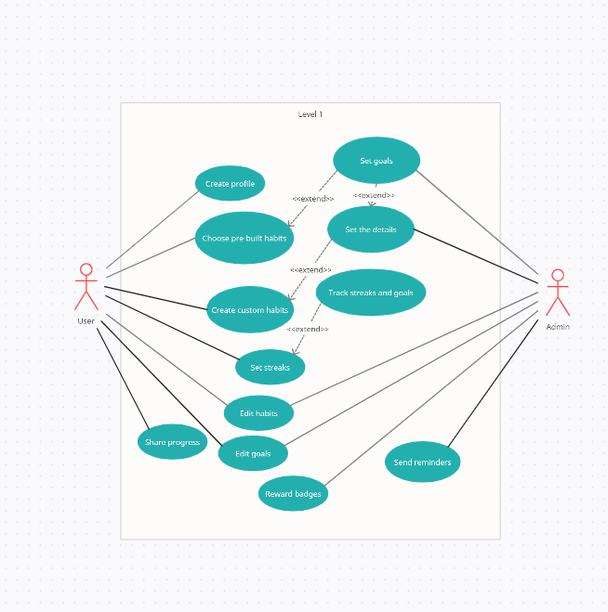

**Prototype**

Here is the Figma prototype that was created for this app. Note that this is just a prototype and there may be multiple updates on the actual UI developed.

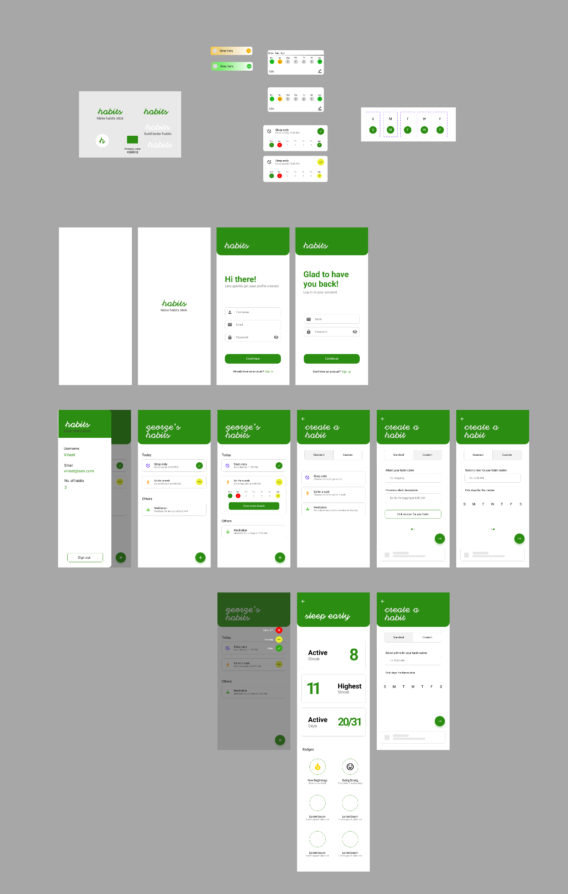

**Implementation**

Since this is an app which requires constant usage throughout the day which also provides you with notifications, we decided to go ahead with Flutter and Firebase for its development.

Flutter is an open source UI software development framework developed by Google. It allows the developers to build high quality, cross platform applications which include the likes of Android and iOS, from a single codebase. It uses the Dart programming language and offers a rich set of pre-built widgets and tools that enable fast and efficient app development.

Firebase is a comprehensive mobile and web development platform provided by Google that offers a suite of backend services and tools that developers can leverage to build, deploy and manage their applications more efficiently. It offers a wide range of features including real-time database, authentication, cloud storage and more.

With the help of a prototype, firstly we identified all the required screens the user would be using on a daily basis which are as follows (it may change as and when need arises):

1. User authentication screen
2. Home screen, where all the habits being tracked by the user are shown
3. Habit creation screen, where the user can choose from the listed habits or create their own
4. A screen for showcasing the progress of the habit, which includes data like active streak, longest streak and visual representation of these

All the above screens were created keeping in mind the UX principles to make sure the users are not lost anywhere at any point in the app.

The home screen consists of two sections, namely, the ‘Today’ and ‘Others’. As the name suggests, the ‘Today’ section consists of the habits that were scheduled for that particular day and the ‘Others’ section includes those habits which were not scheduled for the day. Tapping on any of the habits will show you a week calendar showing the days the user did or did not do the habit. In the habits present in the ‘Today’ section, there is also a button which selects the current status of the habit for the day. It has three states, done, not done and pending. If at the end of the day the habit is marked as pending or not done, it is stored as not done for that day and if it is marked as done then it is stored as done for the day.

In the habit creation screen, there are two tabs, namely Choose and Create. In the create tab, the user has multiple fields like the name of the habit, weekdays to schedule it and the reminders to fill to create a habit. In the choose tab, the user can select any habit they wish from the list and then they simply have to select a time for the reminder. Then they are redirected to the create tab where all the data is pre-filled and they can further edit it if they wish.

On the home screen, if you tap on any of the habits, along with the week calendar there is a button which says ‘View more details’, which redirects you to a screen which includes all the details of the habit you selected like an entire calendar which shows the user whether they did the habit on those days or not using colors. There is also information about the streaks and the number of the days the habit was done. It also includes the badges that the users earn if they reach certain milestones as a part of the reward system. It also includes the functionality to edit or delete the habit.

**Challenges**

One of the key challenges faced while developing this app was that the data of the habit needed to be uploaded to Firebase after reading the current status of the habit so that this data is reflected back to the user in the insights.

We decided to go ahead with the idea of uploading the data to Firebase at midnight rather than as and when the user changes the current status of the habit because then we would have to remove the date from the field of done dates array to put it in field of not done dates array and vice versa again and again. Also, this piece of data doesn’t make much sense to the user for the day as it is visible on the app in the form of an icon in the app.

At first we implemented a solution where theoretically once the clock hits 12 AM on the users’ device, it will upload the necessary data to Firebase while running in the background, but unfortunately it turned out to be a very unreliable method of doing so because of the following reasons:

1. User devices can never be trusted to handle such kinds of operations because the user may have killed the app, or switched off their mobile and many such situations which would cause the data to not be uploaded.
2. With such a system, it would make it very difficult to manage simultaneous logins since both of the devices would try to upload the data at different times causing inconsistency in the database.

We finally implemented a solution where the user device was completely taken out of picture for this operation by developing a Node.js app which directly looks at the database and uploads the necessary data. This eliminates both the above challenges faced while working with background processes.

**Key features**

1. Choose or create your habit: The app provides the users the choice of choosing a habit from our list of pre-built habits for easy creation of one or they can just create and customize their own habit.
2. Streaks: Streaks are an effective way to encourage the users to maintain their habit and avoid breaking the chain, which in turn helps build consistency as well as provides a sense of accomplishment.
3. Rewards system: The app awards the users with badges for the particular habit for reaching certain milestones in their journey which again provide the users motivation to keep going and stay consistent by working harder for more badges.
4. Data-driven insights: Apart from the streaks, the app also provides the users more information like the number of days the habit was done as well as the total percentage of the same which help the user to better understand and identify areas of improvement.
5. Reminders: The users can schedule multiple reminders for each habit which will be received on the device as notifications as scheduled, so that the users do not forget and remain consistent.

**Conclusion**

In conclusion, the development and implementation of the ‘habits’ app successfully addresses the needs and challenges faced by the users in establishing and maintaining positive habits.

To make this app even better, features like integration of Google Fit could be added so that all of the fitness related habits can be tracked easily and more efficiently. It could also utilize the OpenAI API to suggest to the users what they could do to get more efficient at a particular habit being tracked by looking at its data.